Averting the tragedies of the commons: developing an interdisciplinary framework to circumvent the overexploitation of common resources.
Senay Yitbarek
Karen Bailey
tylersh1
jeramie_strickland
DeAnna Beasley
nyeema
shakara
Abstract
Authors

Senay Yitbarek, Karen Bailey, Shakara Tyler, Jasmine Crumsey, Jeramie Strickland, DeAnna E. Beasley, and Nyeema C. Harris
The tragedy of the commons narrative posits that increased demands for common resources depletes available resources to the point that harms all stakeholders. The ecologist Garret Hardin was the first in 1968 to popularize such a view in his essay “tragedy of the commons”. In essence, Hardin argues that strategies driven by short-term self-interests of individuals and nation-states for common resources results in environmental catastrophes ranging from overfishing to the present climate change crisis. Although such a downward spiral is certainly plausible, potential outcomes are far more complex. Recent interdisciplinary research demonstrates that cross-feedbacks between socio-ecological strategies and the environment can lead to changes in incentives potentially mitigating the depletion of resources. In a recent symposium in August 2018, organized by the Black Ecologist section at the annual Ecological Society of America conference held in New Orleans, we reported on this coupled feedback between resource strategies and the environment. By approaching this feedback loop across a range of ecosystems and scales, from microbes to humans, we developed a socio-ecological framework that explores how changes in resource use alters strategies for future action. First, we deconstruct the uses and beneficiaries of the shared resource. Then, we identify potential cascades of conflict across scales explicitly including lens of resource partitioning, plasticity, and mitigation strategies. Nested within these dynamics is an inherent human dimension; though not simply as exploiters but rather as ecosystem mediators. We consider how individual representation of who studies these processes, through the inclusion of black ecologists in the society, can alter the framing and outcome of this ‘tragedy’. The interdisciplinary scholarly work undertaken by black ecologists provides ample hope that the tragedy is not inevitable after all. Through a range of case studies, we identify design principles for managing resources sustainably. We find that inclusive oversight at different spatial and temporal scales can help us cope with the complexity of the commons.

Introduction: setting up the framework in environmental context
@ Karen—–Environmental threats: What are some of the major environmental challenges that exacerbate the tragedy of the commons? Why should we re-frame discussion around the tragedy? How might we bridge the commons issue across different geographical scales, from the local to the global? What role do humans play in mitigating environmental risks?
The tragedy of the commons and the need to re-frame
The concept of the tragedy of the commons, first popularized by Hardin in 1968, posits that the short-term self-interests of individuals for common resources results in environmental catastrophes ranging from overfishing to the present climate change crisis (Hardin 1968). This idea has significantly influenced our understanding of human nature, natural resource use and governance, cooperation, hazard management, and a wide-range of scientific fields (Axelrod and Hamilton 1981, Wisner et al. 2005, Ostrom 2015). While Hardin suggests that the tragedy may be inevitable, applications of the tragedy of the commons often conclude that effective mechanisms to resolve resource conflicts prevent such collapse (Feeny et al. 1990, Milinski et al. 2002, Rankin et al. 2007). As such, there is a growing interest in identifying and understanding the major environmental challenges that intensify the tragedy of the commons and the traits that either exacerbate or mitigate the tragedy (Gersani et al. 2001, Cole et al. 2014, Berger et al. 2016).

Ecologists apply the tragedy of the commons to our investigations of sexual selection and evolution, inter- and intra- specific competition, and social-ecological systems, improving our ability to understand mechanisms that influence system dynamics
These challenges, including population growth, landscape fragmentation, urbanization, migration, and economic globalization, influence use of common pool resources across scales and impact our ability to avoid the tragedy.

Case studies: shared resources within a human context.

@Nyeema—-Protected areas: What is the purpose of protected areas and who’s interests do they tend to serve? How do local people view protected areas? What is the effectiveness of community-based conservation efforts?

@Senay—-Zoonotic diseases: What human activities are driving zoonotic disease dynamics? What makes some hosts great reservoir species? What ecological factors are driving transmission from animals to humans? Can we predict future outbreaks?
Anthropogenic environmental changes threaten human health and increase the risks of infectious diseases (citation). The primary drivers of emerging infectious diseases (EID) are ecological in nature, most of which have been perpetuated by anthropogenic changes (citation). Some of these ecological drivers include changes in land-use such as urbanization, increased global connectance due to transportation of animals and goods, and ecosystem changes such as deforestation (citation). Emerging diseases involves the initial invasion and subsequent spread of pathogen in a new host population.

- Describe how anthropogenic environmental change driving vector-borne disease.
- Emerging infections diseases and zoonotic disease.
- Routes of transmission: direct and indirect pathogen transmission.
- Disease spillover from animals to humans.
- Forcasting outbreaks: identifying critical slowing-down for eid
@Deanna—-Urban spaces: What are some examples by local communities of collectively managing urban resources? What are public and private instruments that can be used to share the urban commons? What do ecological and evolutionary pressures that organisms experience in urban spaces tell us about resilient ecosystems?

Concluding remarks: Incorporating Black Identity into Ecological solutions
@ Shakara—-Social and Political dimension: Who produces the Science and how has Scientific Knowledge traditionally been acquired? What perspective does Black Knowledge provide Ecological Science? What collaborative framework can we propose that includes a Black Perspective into “solving” the commons problem?

Results/Framework: Social-Ecological system

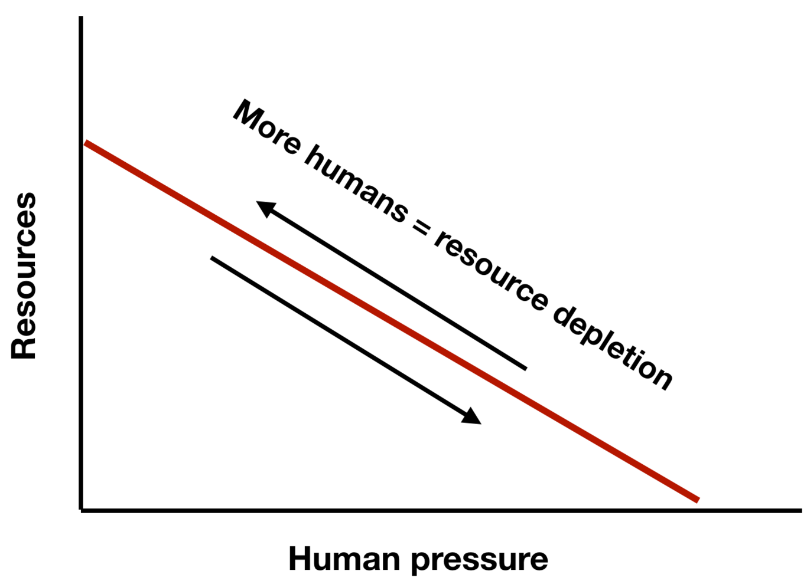
In the linear model (Hardin’s view), the resource tragedy can only be reversed when human pressure is reduced (i.e. one less human means one more available resource). The reverse path is the same as the forward path.
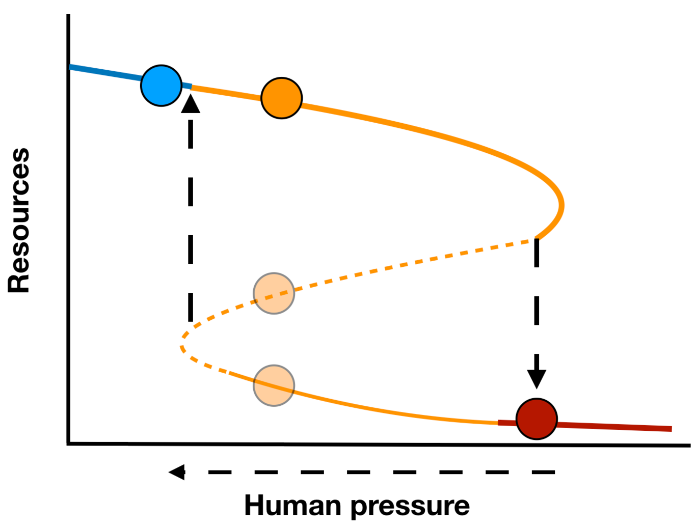
In a resilient framework, alternative stable states lead to hysteretic state whereby the reverse path is not the same as the forward path. Within a range of conditions, humans can maintain the stability of the ecological system. Increasing human pressure beyond a critical point (bend in the curve) will lead to a sudden collapse of the ecosystem. In order for the hysteretic state to return to its previous point, human pressure needs to be reduced to a lower level (horizontal arrow) such that the resource increase again (vertical arrow point). Filled circles indicate stable points in the ecosystem, while opaque circles indicate unstable point.

Discussion
- Discuss how pervasive is the tragedy
- Human interactions with the natural world are not just negative. Persistent bias view of anthropogenic pressures and we ignore contributions to livelihood, spiritually, social cohesion, and professional development
- Identifying the shared resource across systems/scale – land, food, water
- Exploring evasion strategies to avert tragedy of the commons across systems/scales
- One major strategy involves inclusivity on who is doing science and communicating science

